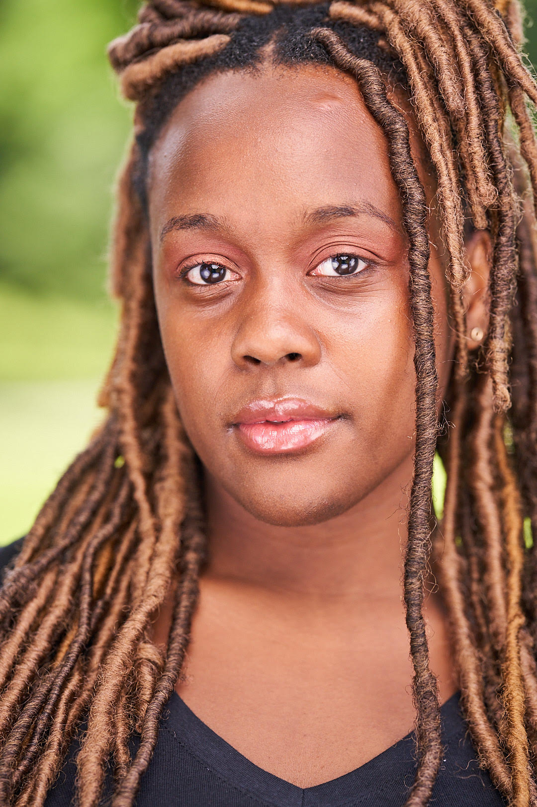
Passionate performer who is reputed for her craft and eager to become an award winning actress
EDUCATION / TRAINING
- University at Albany, SUNY Major: Theater
COURSES:
Acting I Kim Stauffer
Voice and Movement for the actor
Acting II Chad Larabee
Directing
Audition Techniques
Stage Management Renee Bell
Singing Rachel Mackenzie

- Borough of Manhattan Community College, CUNY

Playwriting Savannah Forbes
Music Christine Free
Voice and Articulation Felecia Harrelson

STAGE

- Something’s Got to Give Renee University at Albany, SUNY
- Shattered Doctor/Waitress
- Fresh acts Brandy
- Rebel Verses Vineyard Theatre
- Monologue series The Door

SPECIAL SKILLS

Fluent in Spanish
Singing (Alto - Mezzo Soprano)
Dance : Hip Hop, Salsa, African, Freestyle
Additional : Improvisation, Stage Managing, Great level of Creativity, Communication Skills, Presentation Skills ,Theater Operations, Experience in different media (Stage and Radio) , Poet,
Public Speaker, Squeaky Voice, Running in Heels.

